**MEDICAL INVENTORY MANAGEMENT**

**SREE NARAYANA GURU COLLEGE,**

**K.G CHAVADI,COIMBATORE**

**College Code : bur36**

**TEAM ID : NM2025TMID26473**

**TEAM :**

**Team Leader :**

APARNA. M

[Aparnaappu3917@gmail.com](mailto:Aparnaappu3917@gmail.com)

**Team Member :**

ANAGHA.N

[Anaghananagha1@gmail.com](mailto:Anaghananagha1@gmail.com)

**Team Member :**

ANANNIYA ANIL

[Ananniyaanil231@gmail.com](mailto:Ananniyaanil231@gmail.com)

**Team Member :**

AMRITHESH.A

[dudeamrithesh@gmail.com](mailto:dudeamrithesh@gmail.com)

**Team Member :**

ANSHAD .PS

[Anshadsulaimam336@gmail.com](mailto:Anshadsulaimam336@gmail.com)

**INTRODUCTION**

**1.Project Overview**

Efficient management of medical inventory is crucial for hospitals, pharmacies, and healthcare centers to ensure uninterrupted patient care and avoid shortages or overstocking of essential medicines, equipment, and supplies. A *Medical Inventory Management System (MIMS)* is designed to automate, track, and streamline the handling of medical stock, from procurement to usage, thereby improving operational efficiency and reducing human error.The system maintains a digital record of all medical supplies, including drugs, surgical equipment, disposables, and diagnostic tools. It monitors stock levels, expiry dates, and supplier details in real time, enabling timely replenishment and minimizing wastage due to expired items. The system also generates alerts for low-stock and near-expiry products, helping staff take proactive measures.By integrating reporting and analytics features, the system supports decision-making through insights on consumption patterns, supplier performance, and cost optimization. Additionally, role-based access ensures data security, while barcode/QR code scanning can enhance accuracy in stock updates.Overall, the project aims to provide a reliable, user-friendly, and scalable solution that ensures better resource utilization, reduces operational costs, and ultimately contributes to improved healthcare delivery.

**2.Pourpose**

The main objective of the Medical Inventory Management System is to ensure efficient and accurate handling of medicines, equipment, and other medical supplies within healthcare organizations. The project aims to automate inventory-related processes such as procurement, stock updates, and reporting in order to reduce human errors and save time. It focuses on monitoring the availability of medical items in real time, preventing both shortages and overstocking, while also keeping track of expiry dates to minimize wastage and ensure patient safety. The system will provide timely alerts for low-stock or near-expiry items, enabling staff to take proactive measures. Additionally, it will streamline supplier and purchase management by maintaining supplier details, tracking orders, and analyzing purchasing trends for cost efficiency. Role-based access control will enhance security by allowing only authorized users to manage sensitive data. By generating analytical reports and insights on usage patterns, the system will support better decision-making and resource allocation. Ultimately, the objective of the project is to provide a reliable, scalable, and user-friendly solution that guarantees uninterrupted availability of essential medical resources, reduces operational costs, and improves the overall quality of healthcare delivery.

**DEVELOPMENT PHASE**

1. **Creating Development Account:**

**By using this URL -** [**https://developer.salesforce.com/signup**](https://developer.salesforce.com/signup)

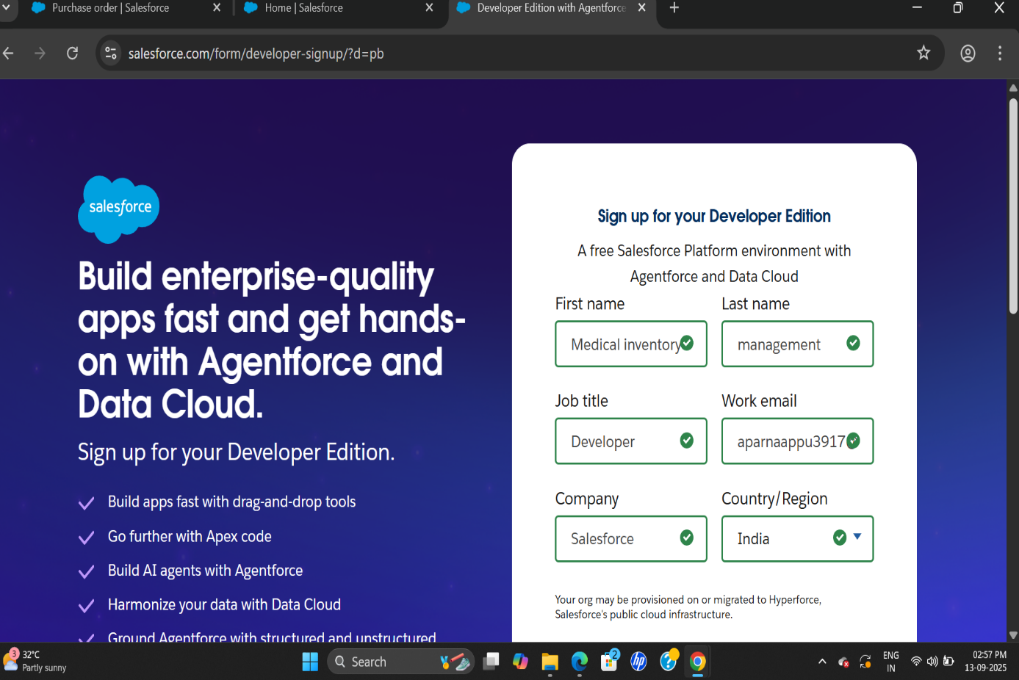

1. Created Object : Product, Purchase Order, Order Item, Inventory Transaction and Supplier objects. -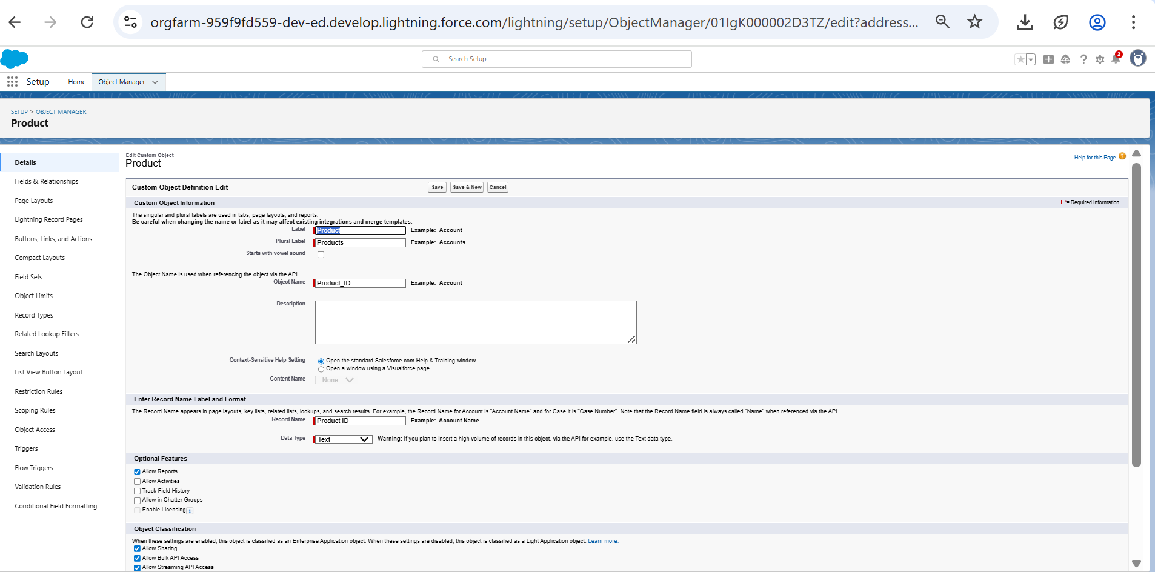--

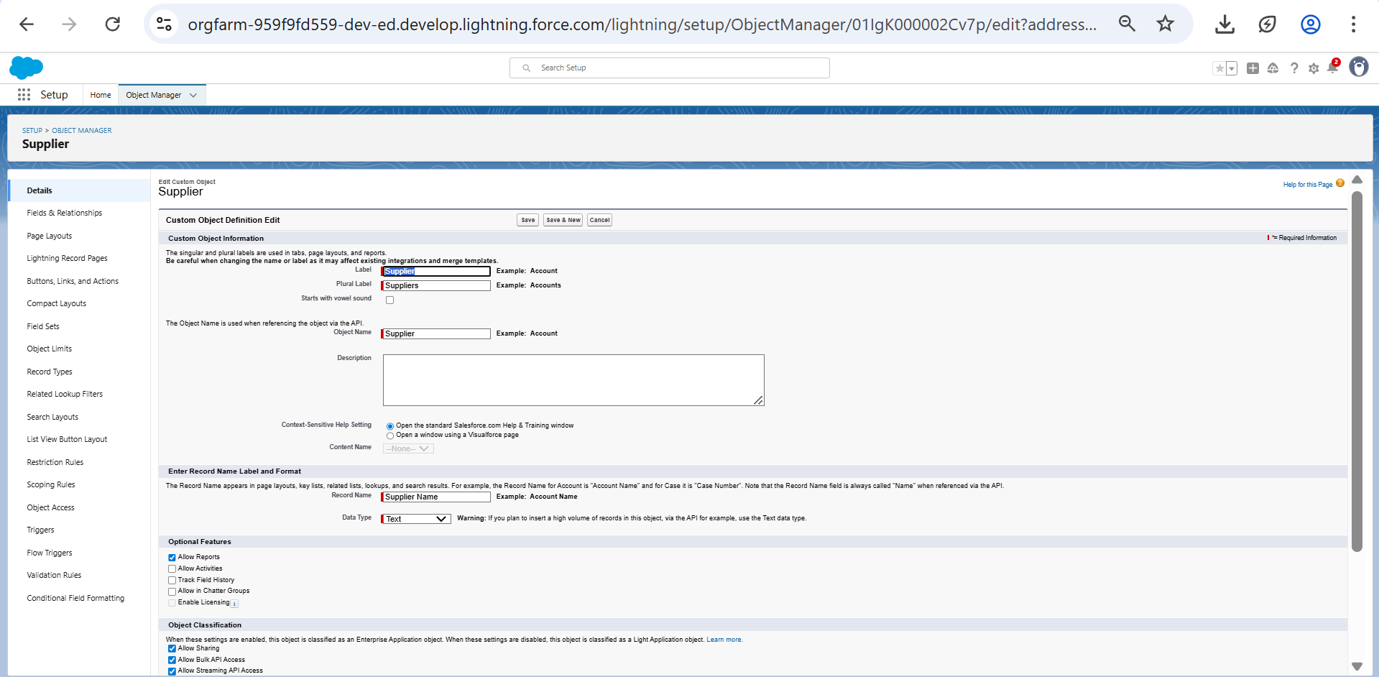

1. Tabs

**4.**Developed Lightning App

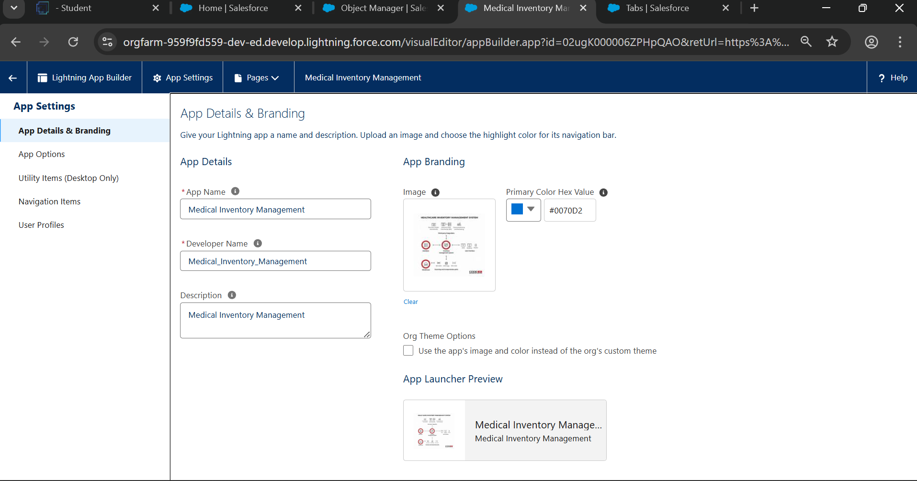

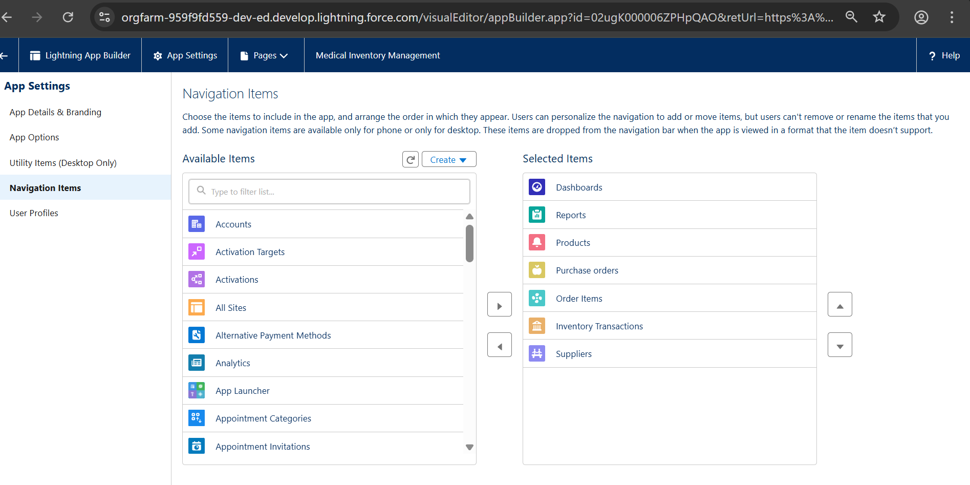

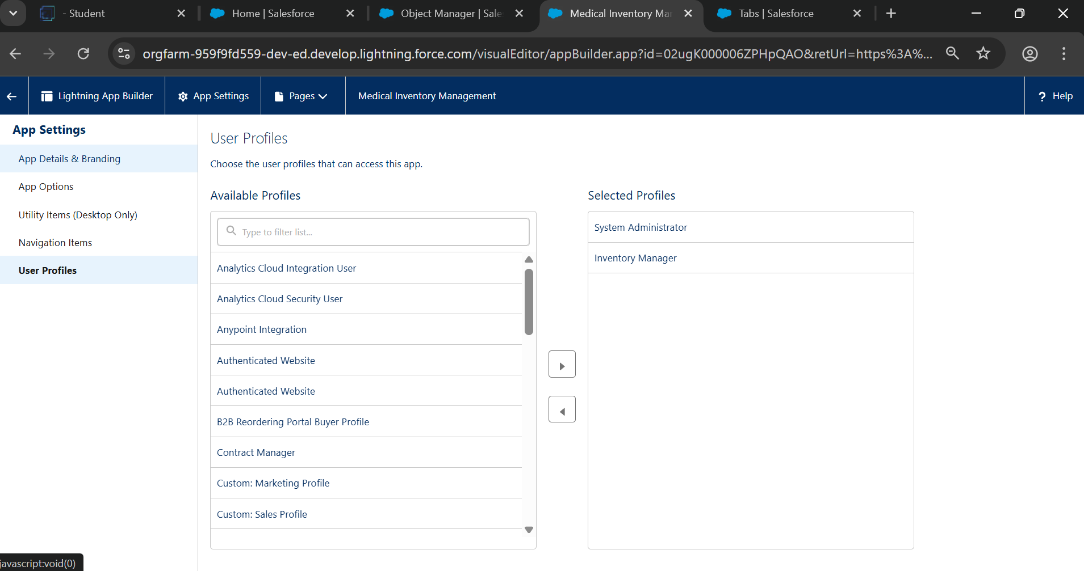

**5.** Fields likes :current stock level, minimum stock level, product description, product ID,product name,unit price

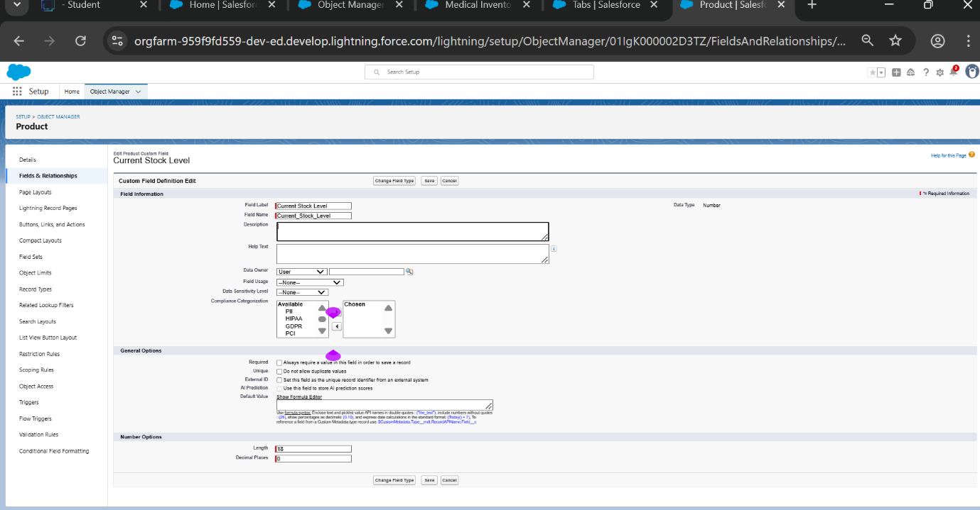

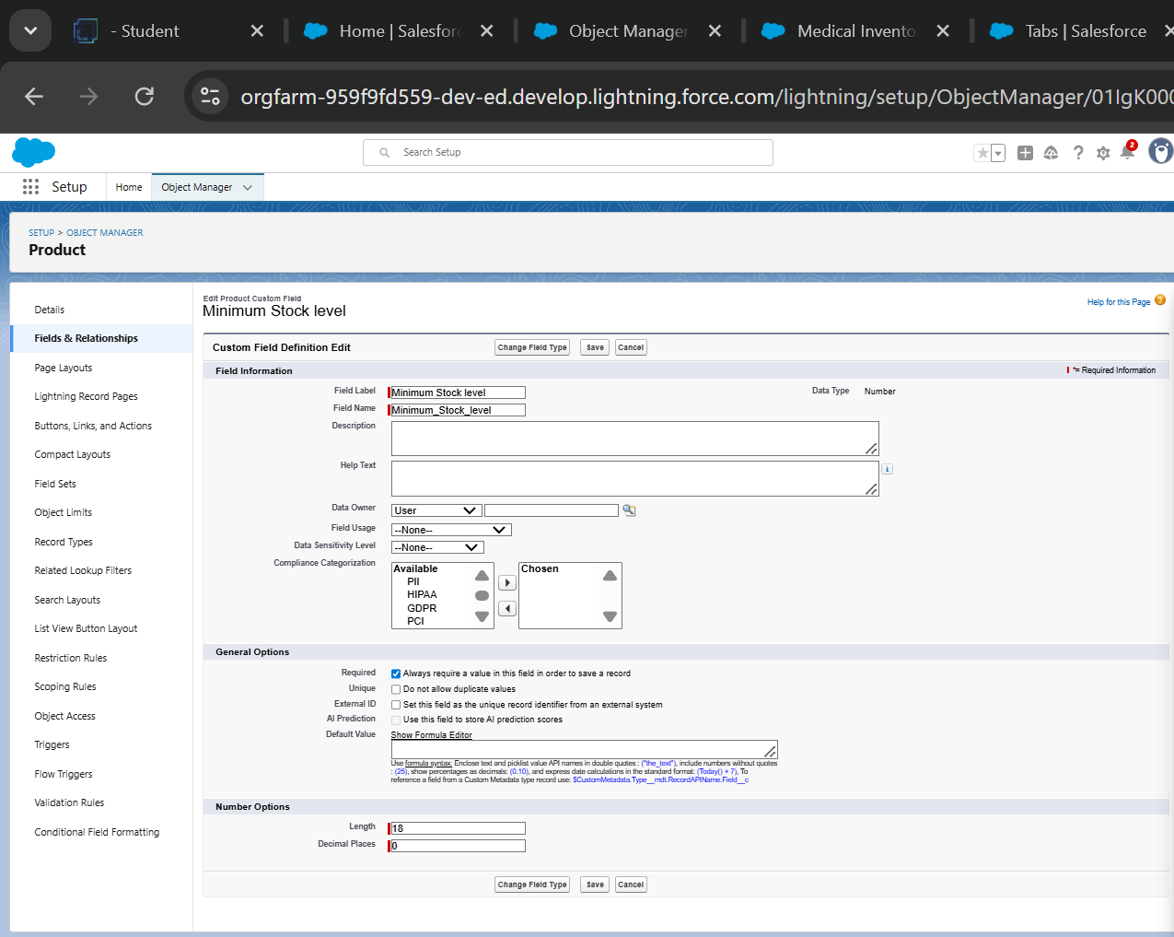

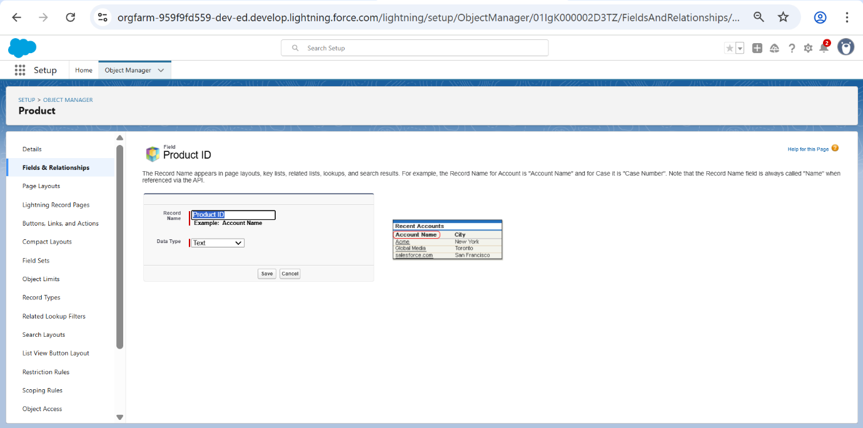

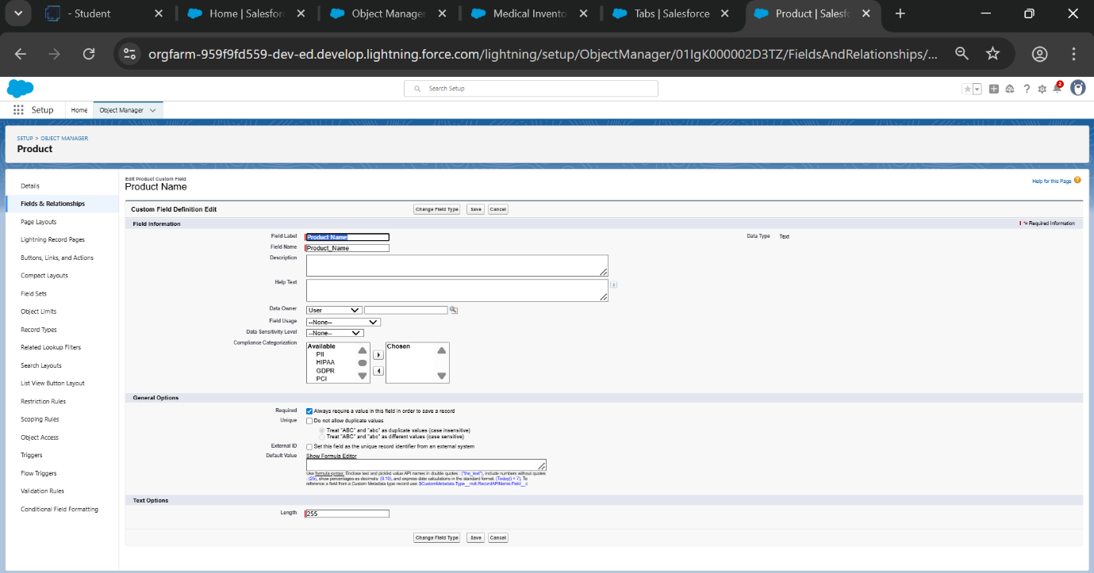

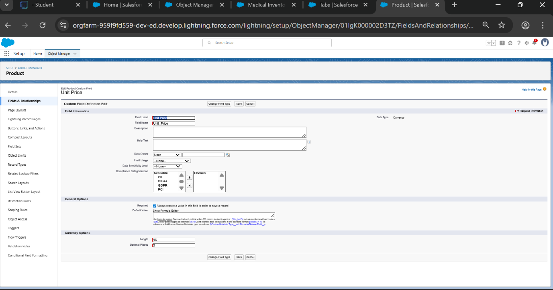

**6.** Editing of Page Layouts: Product Object ,Purchase Order Object,Order Item Object, inventory transaction, supplier object.

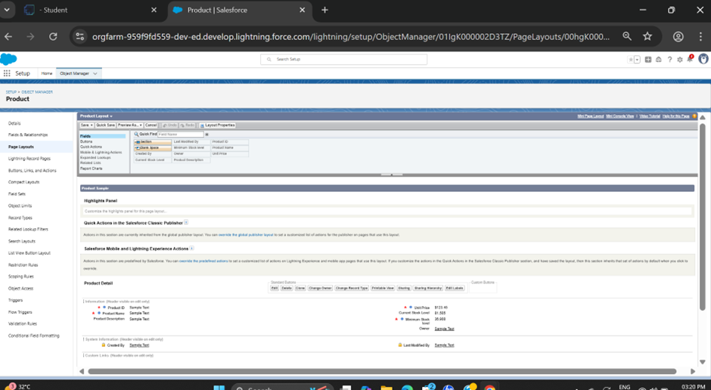

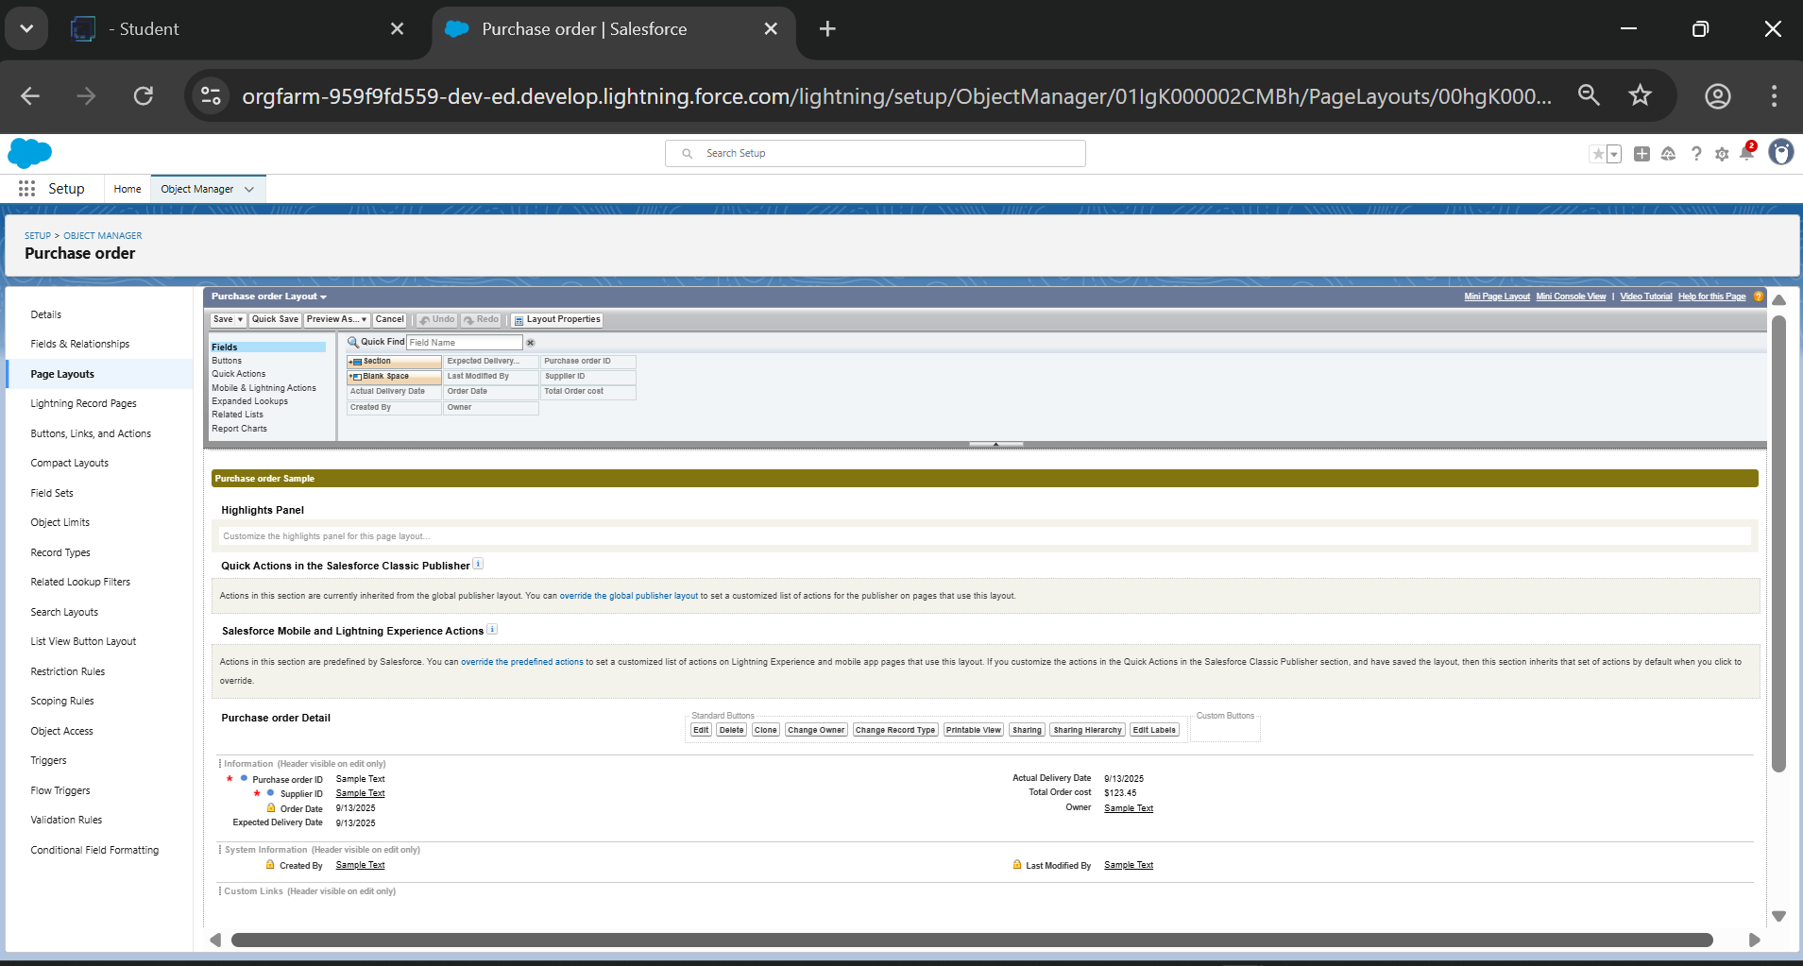

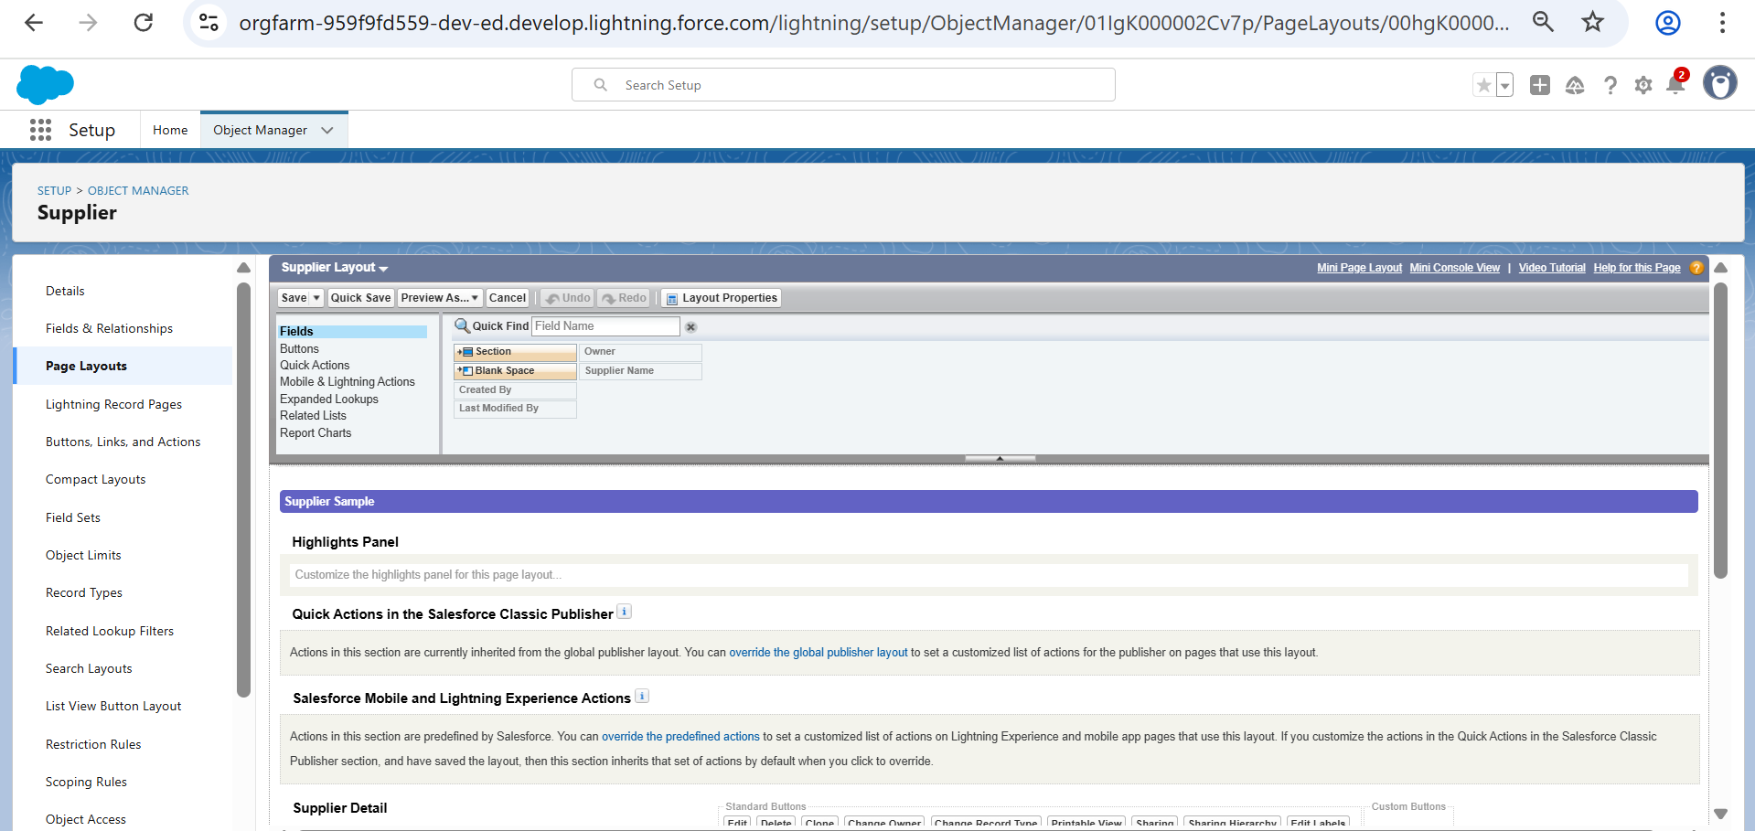

**7.**Compact layouts: Product object, Purchase object

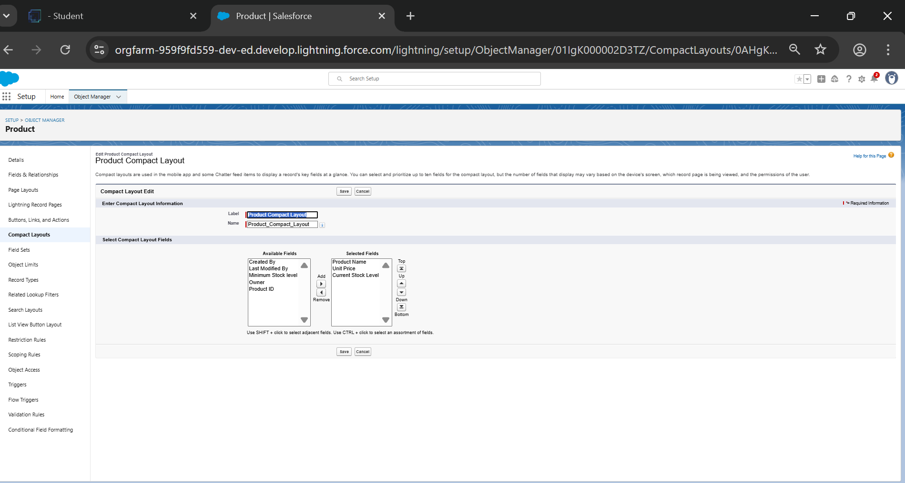

**8.** Validation rules

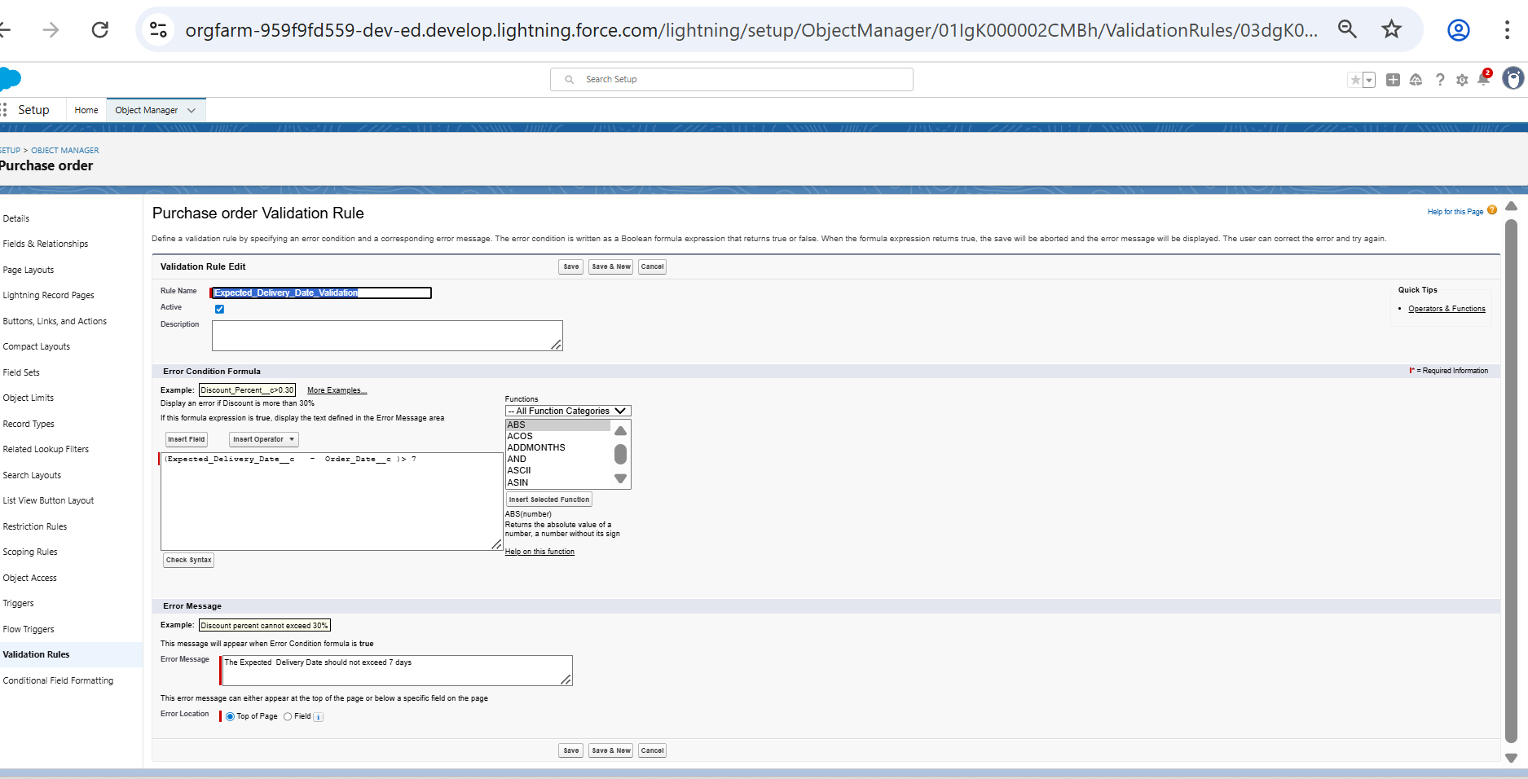

**9.** Profiles: Inventory Manager Profile, Purchase Manager Profile

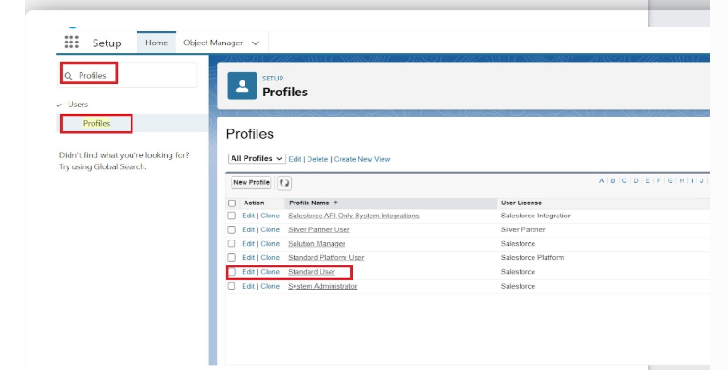

**--**

**10**. Permission Sets

**11.** Flows

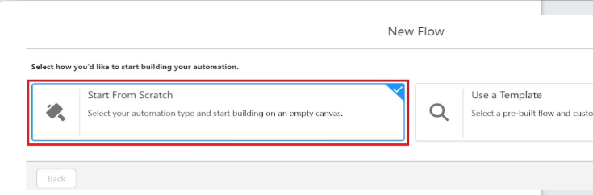

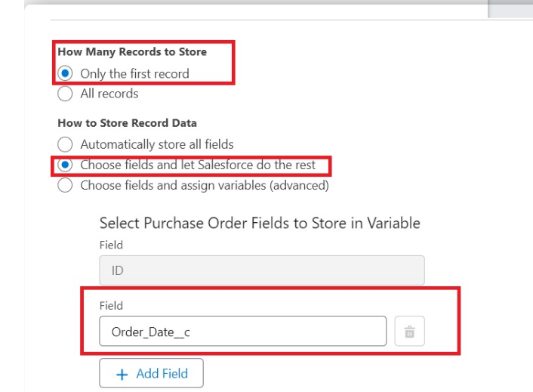

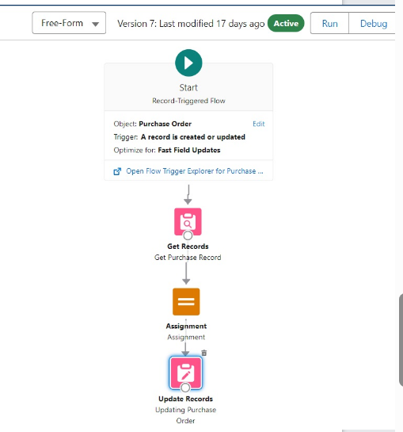

**11.**Triggers

**12.**Reports

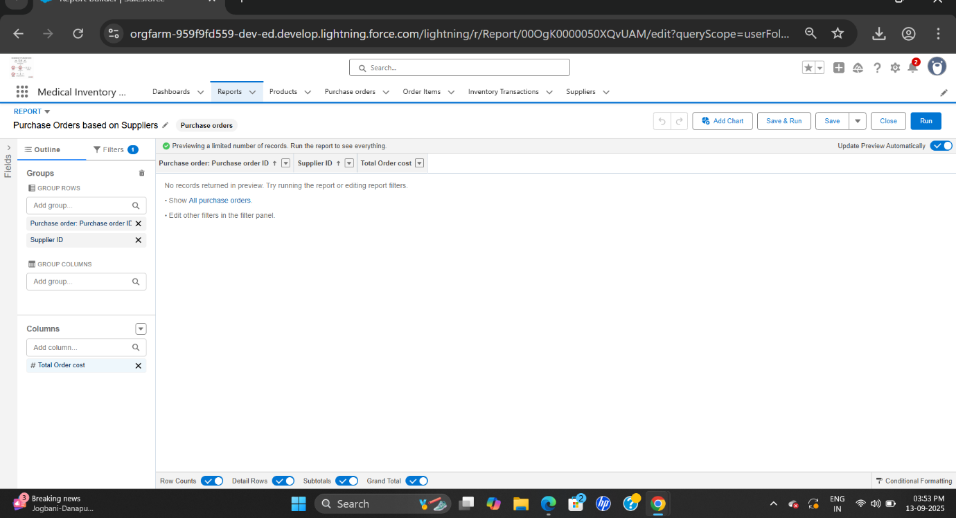

**12.** Dashboards

**ADVANTAGE & DISADVANTAGE**

**ADVANTAGES**

1. Ensures accurate tracking of medicines, equipment, and supplies.

2. Prevents shortages and overstocking of medical items.

3. Reduces wastage by monitoring and managing expiry dates.

4. Automates stock management, saving time and reducing human errors.

5. Provides real-time visibility of inventory levels across departments.

6. Sends alerts for low-stock and near-expiry products.

7. Simplifies supplier and purchase order management.

8. Generates analytical reports for better planning and decision-making.

9. Improves data security with role-based user access.

10. Enhances operational efficiency and reduces overall costs.

11. Supports scalability and integration with other healthcare systems.

12. Ensures uninterrupted availability of resources, improving patient care.

**DISADVANTAGES**

**1. High Initial Cost** – Developing or purchasing the system requires significant investment in software, hardware, and setup.

**2. Training Requirement** – Staff must be trained to use the system effectively, which can take time and resources.

**3. Technical Issues** – System failures, bugs, or downtime may disrupt inventory operations and affect healthcare services.

**4. Dependency on Technology** – Over-reliance on the system can be risky if there is a power outage, internet failure, or technical breakdown.

**5. Data Security Concerns** – If not properly secured, sensitive medical and supplier data can be vulnerable to cyberattacks or misuse.

**6. Maintenance Costs** – Regular system updates, security patches, and technical support may add to long-term expenses.

**7. Customization Limitations** – Some systems may not fully meet the specific needs of every hospital or pharmacy without costly customization.

**8. Resistance to Change** – Some staff may find it difficult to adapt from manual methods to digital inventory systems.

**9. Integration Challenges** – Linking the system with existing hospital or pharmacy management software can sometimes be complex.

**10. Data Entry Errors** – Incorrect data input at the initial stage can lead to inaccurate reports or stock mismatches.

**CONCLUSION**

Medical Inventory Management System plays a vital role in improving the efficiency, accuracy, and reliability of healthcare operations. By automating stock management, tracking expiry dates, and providing real-time updates, the system helps reduce human error, prevent wastage, and ensure the uninterrupted availability of essential medical resources. Although it comes with certain challenges such as high initial costs, training requirements, and dependency on technology, the long-term benefits outweigh these limitations. The system not only enhances operational efficiency and cost-effectiveness but also supports better decision-making through data-driven insights. Ultimately, the Medical Inventory Management System contributes to improved patient care, streamlined resource utilization, and stronger healthcare delivery, making it an essential solution for modern hospitals, pharmacies, and healthcare centers.

**APPENDIX**

Source code : Provided in Apex classes and Triggers

**Apex Trigger**:

trigger CalculateTotalAmountTrigger on Order_Item__c (after insert, after update, after delete, after undelete) {

    // Call the handler class to handle the logic

    CalculateTotalAmountHandler.calculateTotal(Trigger.new, Trigger.old, Trigger.isInsert, Trigger.isUpdate, Trigger.isDelete, Trigger.isUndelete);

}

**Apex Classes:**

public class CalculateTotalAmountHandler {

    // Method to calculate the total amount for Purchase Orders based on related Order Items

    public static void calculateTotal(List<Order_Item__c> newItems, List<Order_Item__c> oldItems, Boolean isInsert, Boolean isUpdate, Boolean isDelete, Boolean isUndelete) {

        // Collect Purchase Order IDs affected by changes in Order_Item__c records

        Set<Id> parentIds = new Set<Id>();

        // For insert, update, and undelete scenarios

        if (isInsert || isUpdate || isUndelete) {

            for (Order_Item__c ordItem : newItems) {

                parentIds.add(ordItem.Purchase_Order_Id__c);

            }

        }

        // For update and delete scenarios

        if (isUpdate || isDelete) {

            for (Order_Item__c ordItem : oldItems) {

                parentIds.add(ordItem.Purchase_Order_Id__c);

            }

        }

        // Calculate the total amounts for affected Purchase Orders

        Map<Id, Decimal> purchaseToUpdateMap = new Map<Id, Decimal>();

        if (!parentIds.isEmpty()) {

            // Perform an aggregate query to sum the Amount__c for each Purchase Order

            List<AggregateResult> aggrList = [

                SELECT Purchase_Order_Id__c, SUM(Amount__c) totalAmount

                FROM Order_Item__c

                WHERE Purchase_Order_Id__c IN :parentIds

                GROUP BY Purchase_Order_Id__c

            ];

            // Map the result to Purchase Order IDs

            for (AggregateResult aggr : aggrList) {

                Id purchaseOrderId = (Id)aggr.get('Purchase_Order_Id__c');

                Decimal totalAmount = (Decimal)aggr.get('totalAmount');

                purchaseToUpdateMap.put(purchaseOrderId, totalAmount);

            }

            // Prepare Purchase Order records for update

            List<Purchase_Order__c> purchaseToUpdate = new List<Purchase_Order__c>();

            for (Id purchaseOrderId : purchaseToUpdateMap.keySet()) {

                Purchase_Order__c purchaseOrder = new Purchase_Order__c(Id = purchaseOrderId, Total_Order_cost__c = purchaseToUpdateMap.get(purchaseOrderId));

                purchaseToUpdate.add(purchaseOrder);

            }

            // Update Purchase Orders if there are any changes

            if (!purchaseToUpdate.isEmpty()) {

                update purchaseToUpdate;

            }

        }

    }

}